SQL Exercises

***https://www.w3schools.com/sql/trysql.asp?filename=trysql_desc***

1. Show all rows for Customers



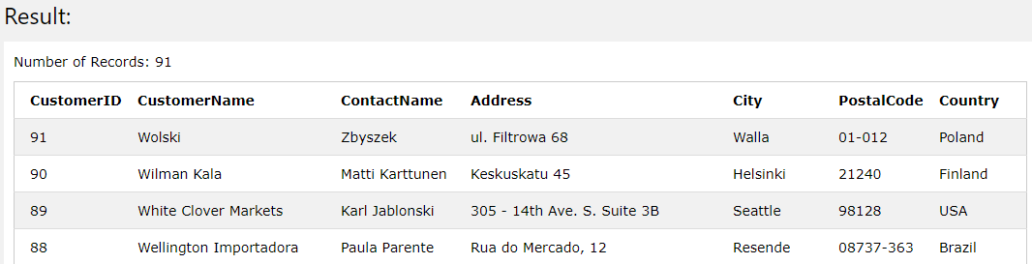

1. Show only Contact name information for Customers

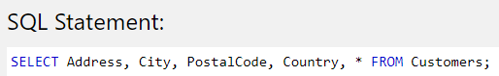

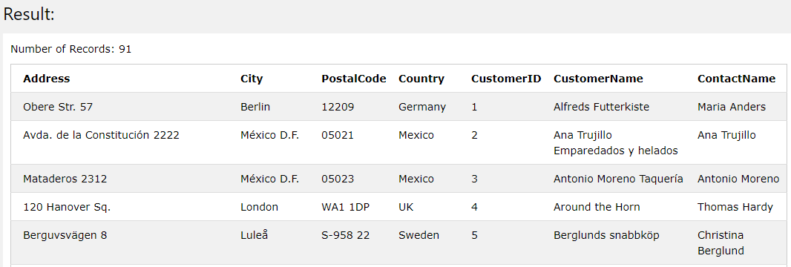

1. Show all unique combinations between Cities and Countries for the customers



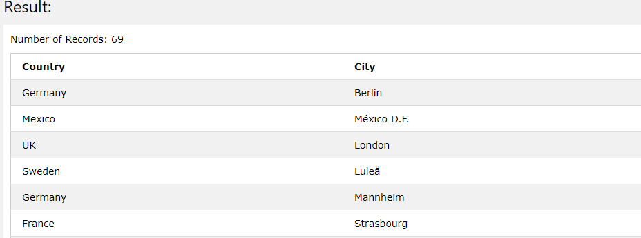

1. Insert 3 new Customers

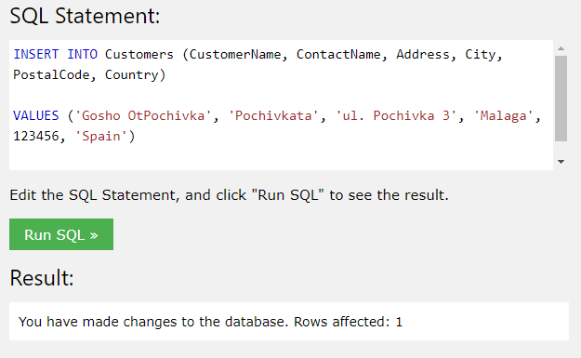

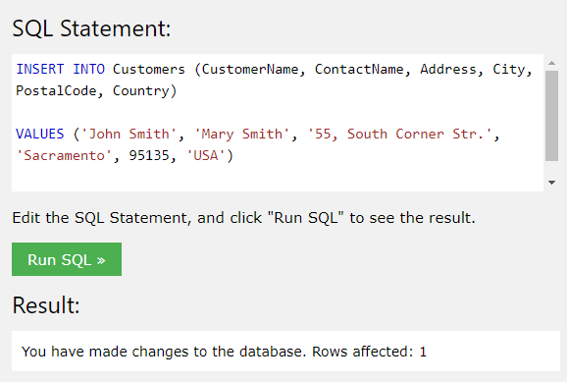

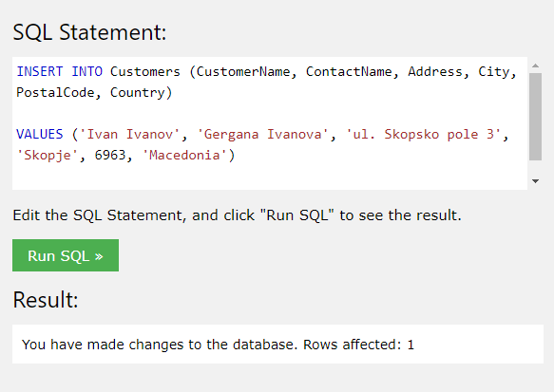

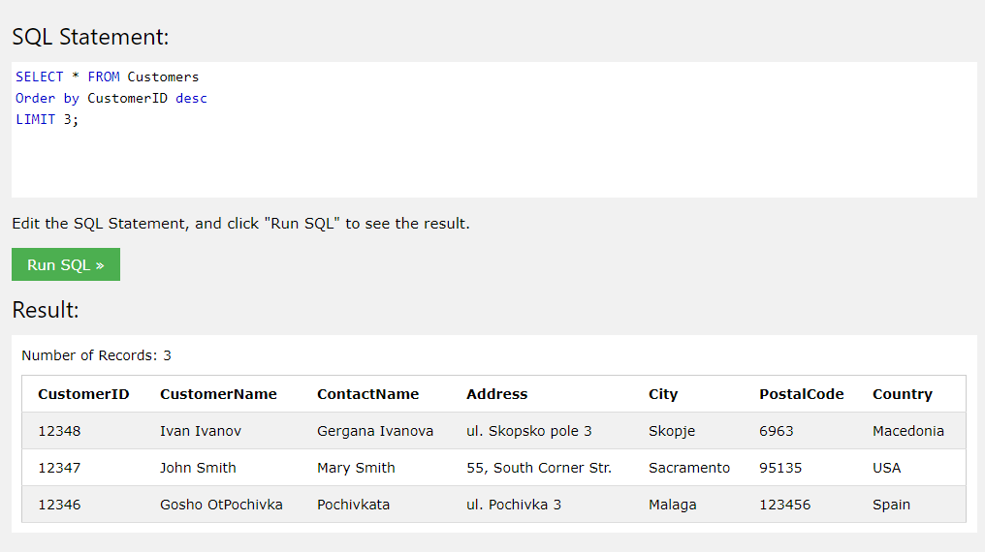

1. Move all orders made by Andrew Fuller to Nancy Davolio

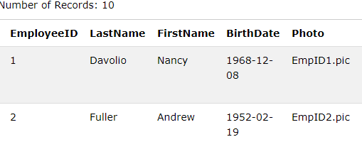

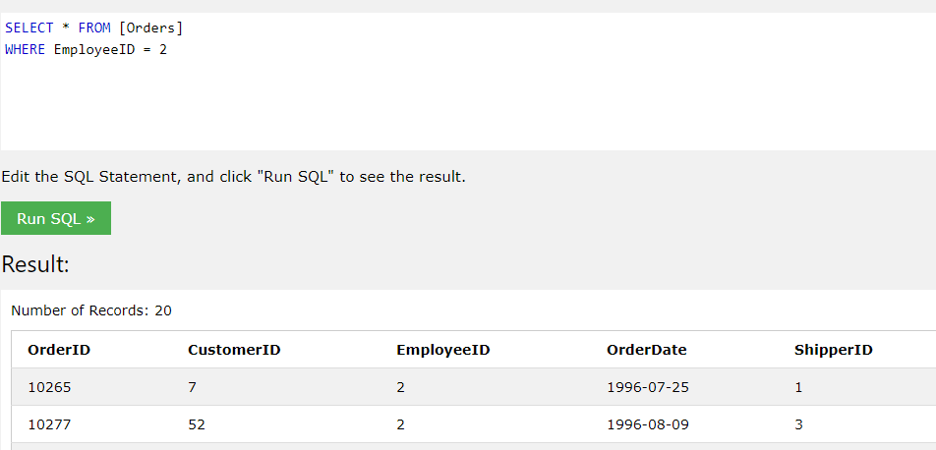

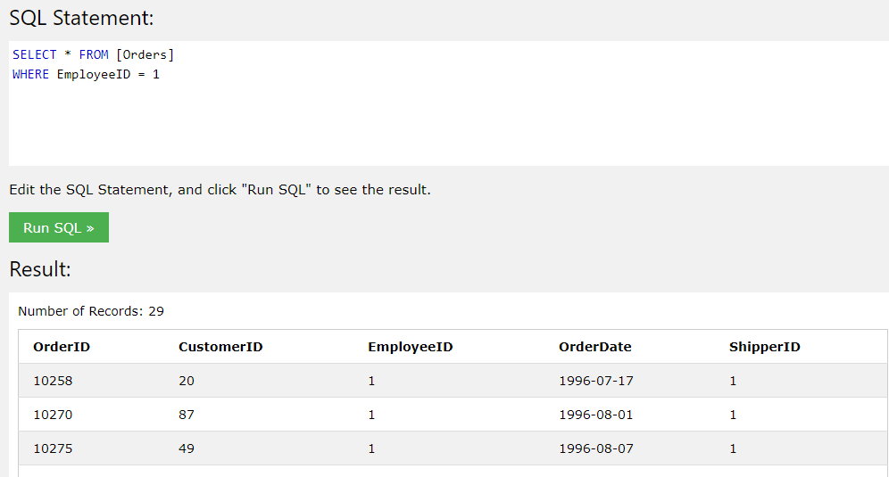

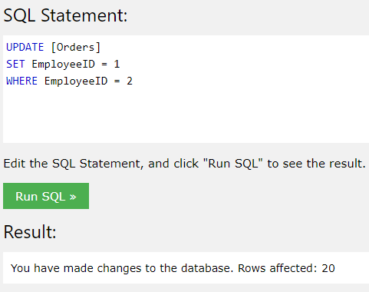

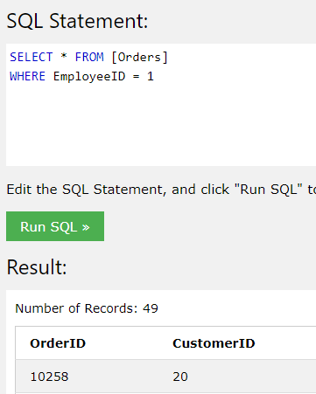 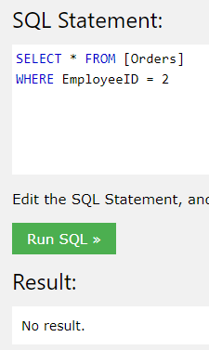

1. Group all products by category and show category name

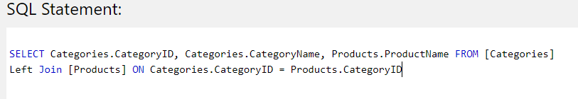

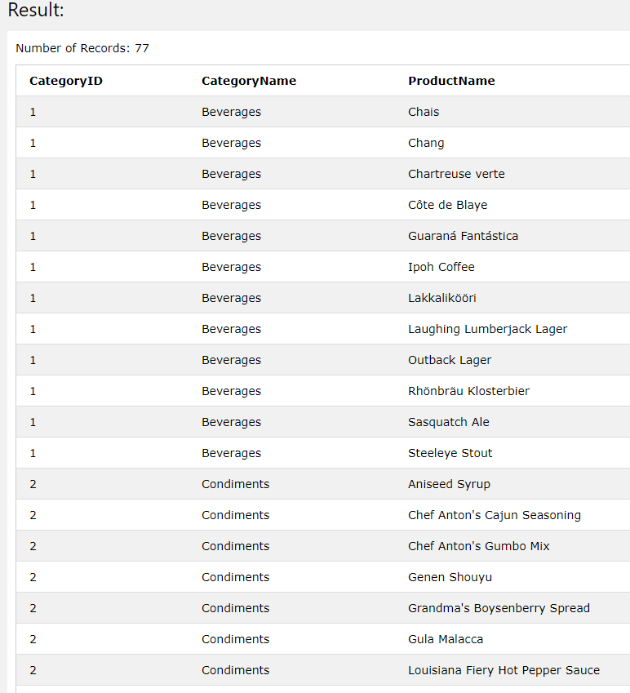

1. Sort all employees by Last Name and delete the last one. Do not remember to move all his/her orders to another colleague

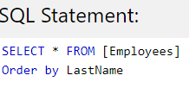

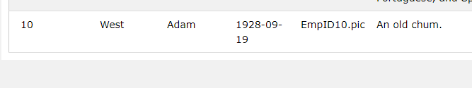

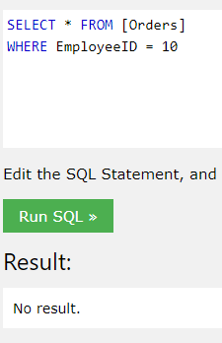 - nothing to move

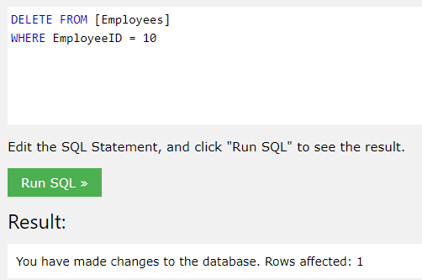

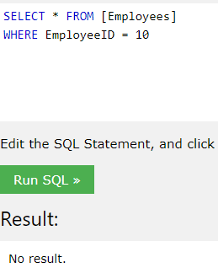

1. Show all customers without orders

Not sure how to do that with a single statement. Personally I would run the query to check which are the customers that have an order:

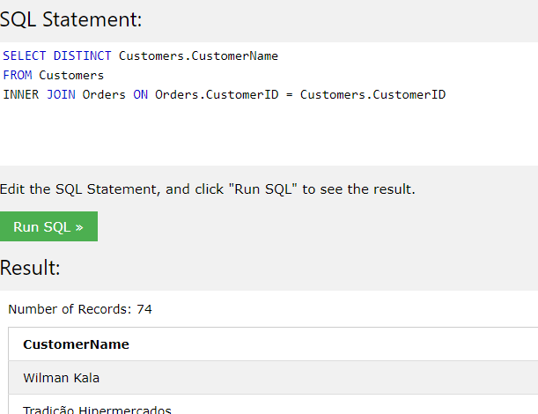

Then try a query like this one, but I guess it’s wrong:

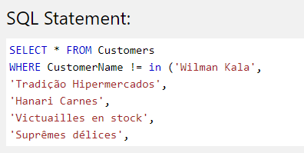

SELECT * FROM Customers

WHERE CustomerName != in ('Wilman Kala',

'Tradição Hipermercados',

'Hanari Carnes',

'Victuailles en stock',

'Suprêmes délices',

'Chop-suey Chinese',

'Richter Supermarkt',

'Wellington Importadora',

'HILARIÓN-Abastos',

'Ernst Handel',

'Centro comercial Moctezuma',

'Old World Delicatessen',

'Que Delícia',

'Rattlesnake Canyon Grocery',

'Folk och fä HB',

'Blondel père et fils',

'Wartian Herkku',

'Frankenversand',

'GROSELLA-Restaurante',

'White Clover Markets',

'Split Rail Beer & Ale',

'QUICK-Stop',

'Vins et alcools Chevalier',

'Magazzini Alimentari Riuniti',

'Tortuga Restaurante',

'Morgenstern Gesundkost',

'Berglunds snabbköp',

'Lehmanns Marktstand',

'Romero y tomillo',

'LILA-Supermercado',

'Ricardo Adocicados',

'Reggiani Caseifici',

'B's Beverages',

'Comércio Mineiro',

'Hungry Owl All-Night Grocers',

'Die Wandernde Kuh',

'Godos Cocina Típica',

'Lonesome Pine Restaurant',

'Ana Trujillo Emparedados y helados',

'The Big Cheese',

'Du monde entier',

'Island Trading',

'Pericles Comidas clásicas',

'Königlich Essen',

'Save-a-lot Markets',

'Bólido Comidas preparadas',

'Furia Bacalhau e Frutos do Mar',

'Bon app',

'Mère Paillarde',

'Princesa Isabel Vinhoss',

'Simons bistro',

'Familia Arquibaldo',

'La maison d'Asie',

'Piccolo und mehr',

'Around the Horn',

'Seven Seas Imports',

'Drachenblut Delikatessend',

'Eastern Connection',

'Antonio Moreno Taquería',

'Galería del gastrónomo',

'Vaffeljernet',

'Queen Cozinha',

'Wolski',

'Hungry Coyote Import Store',

'Santé Gourmet',

'Bottom-Dollar Marketse',

'LINO-Delicateses',

'Ottilies Käseladen',

'Folies gourmandes',

'Océano Atlántico Ltda.',

'Franchi S.p.A.',

'Gourmet Lanchonetes',

'Consolidated Holdings',

'Toms Spezialitäten')

1. Show all products including 'ch' in its name with price between 10 and 20

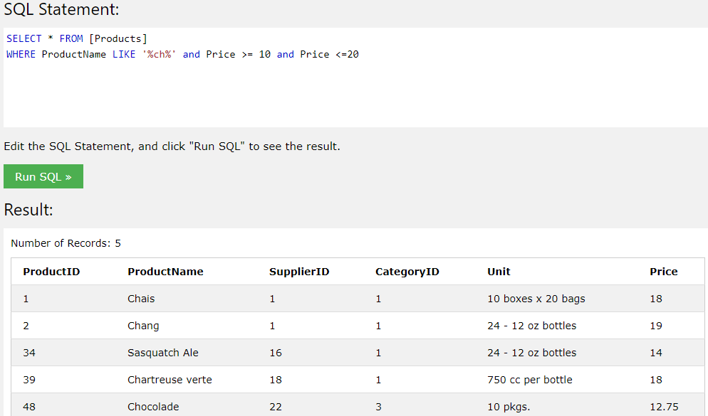

1. Group all products from 9 by category and sort by count in descending order

Not sure what you mean ☺

Perform also a JOIN statement (each of them)